Contents

Main capabilities 1

**Build Guide** 1

**User Guide for MIT Gen 1 Chamber** 9

**Maintenance and Troubleshoot Guide** 13

**Bill of Materials** 15

**Extra Data** 19

**MIT Gen 1 Chamber Build Guide, User Guide, Bill of Materials**

Main capabilities

* Humidity Range: from room humidity (approx. 25 %) to 85 ± 5 %
* Temperature Range: from room temperature to approx. 100 ± 2 °C
* Illumination Range: 0.15 ± 0.01 Sun (or 0-0.15 Sun with the supplementary version of the control program with intensity control, visible light only)
* Samples: Up to 28 1 inch by 0.5 inch samples per sample holder, at maximum two lamp-sample holder combinations per chamber
* Measurement Frequency: Limited by storage only

# **Build Guide**

Note: This build guide is to be used in conjunction with the MIT Gen 1 Chamber CAD Design. These steps will reference the 3D design. Please use a CAD software that can visualize .STEP files so that you can follow along with the instructions.

See Bill of Materials for the detailed list of components.

**Chamber**

1. Remove the lids from both storage boxes.
2. Attach foam insulation tape to the rims of the box that becomes chamber floor. The tape will reduce the amount of fume released from the degrading samples escaping into room air. Use increased ventilation in the room. Use also fume hood if the samples are expected to release toxic substances in gas form.
3. Optional: prepare the touch point pieces for the fold back clips and attach them to the rims. See Figure I for bending instruction.

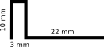

Figure I: Side measurements for the touch point pieces.

1. Use the fold back clips for attaching the chamber ceiling storage box on top of the chamber floor (see Figure II illustrating the closing mechanism and black insulating tape). Check that the seam is closed. Cut through-holes to the insulation tape in the later stages if the USB cables are thick enough to open the seam of the two boxes.

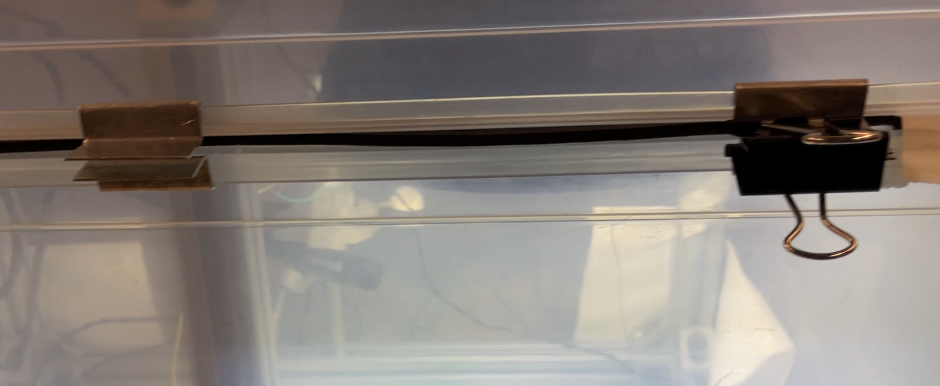

Figure II: Touch point pieces, fold-back clips and black insulation tape seal the gap between the chamber floor and ceiling.

1. Check that the black-out curtains can be folded so that they cover the chamber completely. This is essential for achieving camera data with consistent quality, it will also reduce condensation of water to uncovered regions of the chamber wall.

**Support Frame**

1. Assemble the frame according to the measurements in the CAD file.
2. Leave three corner brackets with sliding slot aside (for attaching the water reservoir and camera).
3. Place the frame inside the floor box.

**Lamp**

1. Attach the lamp to the Al frame according to manufacturer's instructions and CAD illustration.
2. Connect the lamp driver to the lamp and DC power supply according to manufacturer’s instructions. 0-10V analog control is the preferrable control option, but the user may choose the active low gate option if only maximum intensity lamp on/off is required.
3. Check that the lamp hangs horizontally from the frame. If not horizontal, add more support to Al frame. A tilted lamp will add gradient to the illumination intensity across sample holder, reducing data quality.

**Camera setup**

1. Attach the camera lens to the camera according to manufacturer’s instructions. Connect the camera to the control laptop with a (preferably flat) USB cable.
2. Use a corner bracket with sliding slots and a plastic bolt for attaching the camera to look through the hole in the lamp dome (Figure III). The camera should be fully horizontal. Use ThorCam software (provided by the camera manufacturer) to produce a live feed from camera. Fine-tune camera position and lens aperture until a focused view of the intended sample holder area (with no reflections from the lamp dome) is reached. Use the screw lock in the lens to fix the aperture setting, and confirm that the camera is firmly attached to its position.

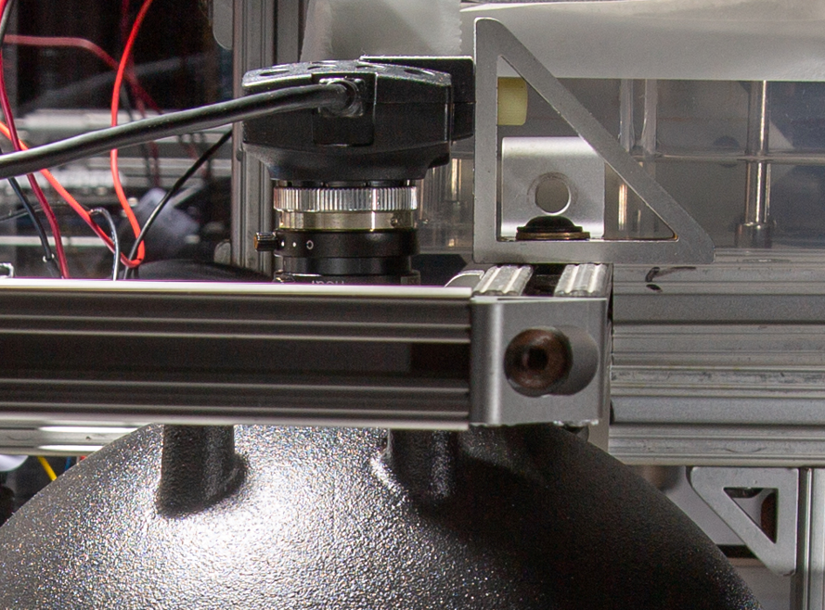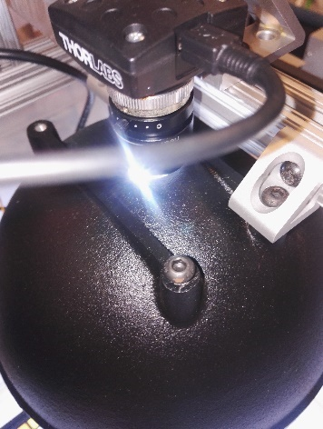

Figure III: The camera is attached to the Al frame to look through the hole in the lamp dome.

**Color calibration setup**

1. Attach the printed color chart to chamber floor so that it remains within the picture area but is not in the sample holder area. Attach the chart so that it is horizontal in the camera view and the white color patch is in the lower left corner in the picture (Figure IV). This alignment is assumed by the image analysis codes we provide.
2. Check that XRite color chart can be placed into the picture area so that it is fully visible, fully horizontal in the chamber floor, properly aligned in the image (horizontal and the white patch in the lower left corner in the picture) and at the same height than the samples would be in the sample holder. Deviations from this setting may cause less accurate color calibration and lower quality of data.

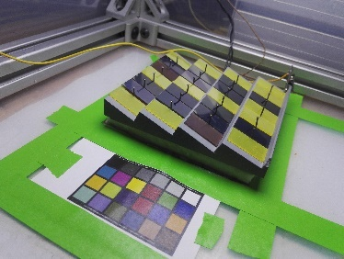

Figure IV: Printed color chart and the sample holder (consisting of the graphite sample holder, sample alignment pins, resistive heating element (not visible in the image), and insulating pad to protect chamber floor from heat.

**Humidity control setup**

1. Prepare an opening lid for the water reservoir (one can use the lid of the water reservoir or just any plastic sheet taped from one side on top of the reservoir). The lid should be easy to lift for filling up and emptying the reservoir. The lid does not have to be tightly sealed. Cut a hole to the lid and attach an 80mm fan to the lid with matching screws. The fan should blow air out from the reservoir.
2. Mark a line 25 mm up from the bottom of the reservoir. This will be the water level the reservoir is always filled up to. The same level should always be used, otherwise the humidity ramp up time may deviate between the aging tests and cause slight differences in the degradation patterns of the samples.
3. Attach the water reservoir to the Al frame using two corner brackets with sliding slots to the location shown in the CAD drawing. Make sure the reservoir is firmly attached to prevent accidents with water.
4. Attach two 120 mm fans to locations shown in the CAD drawing. The placement is designed to allow smooth air flow without turbulence across the chamber, reaching also the corners of the chamber. The sufficient circulation depends on the conditions in the measurement room, and the targeted humidity and temperature within the chamber. Adjust the positions of the fans, increase the number of fans, or add sheets guiding air flow if there is too much condensation (an area with too little air flow) or if the humidity in the chamber creeps up over time (water reservoir is hit by too much air flow).
5. Connect the 120 mm fans to a DC power supply.
6. Connect the 80 mm fan, electric components, Si7021 sensor, and 24 V power supply to Arduino, and Arduino to the laptop (preferably via a USB Hub) according to the circuit shown in Figure V. Place the connected components inside a electrical board box to protect the connections from getting loose.
7. Attach Si7021 sensor close to the sample holder area but so that it does not shade the sample holder or the printed color chart (connected to the laboratory bench holder in Figure VI). Never touch the white patch in the sensor, that getting dirty may reduce the accuracy of the sensor. Optional: The sensor may be protected from accidental touches by forming a protective Nailon enclosure by melting down Nailon net with a soldering tip.

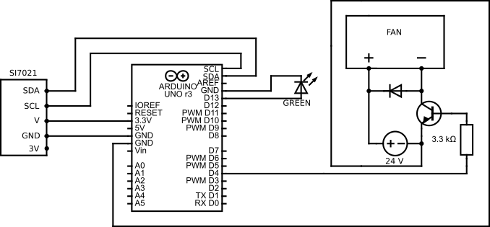

Figure V: Circuit for the humidity control system.

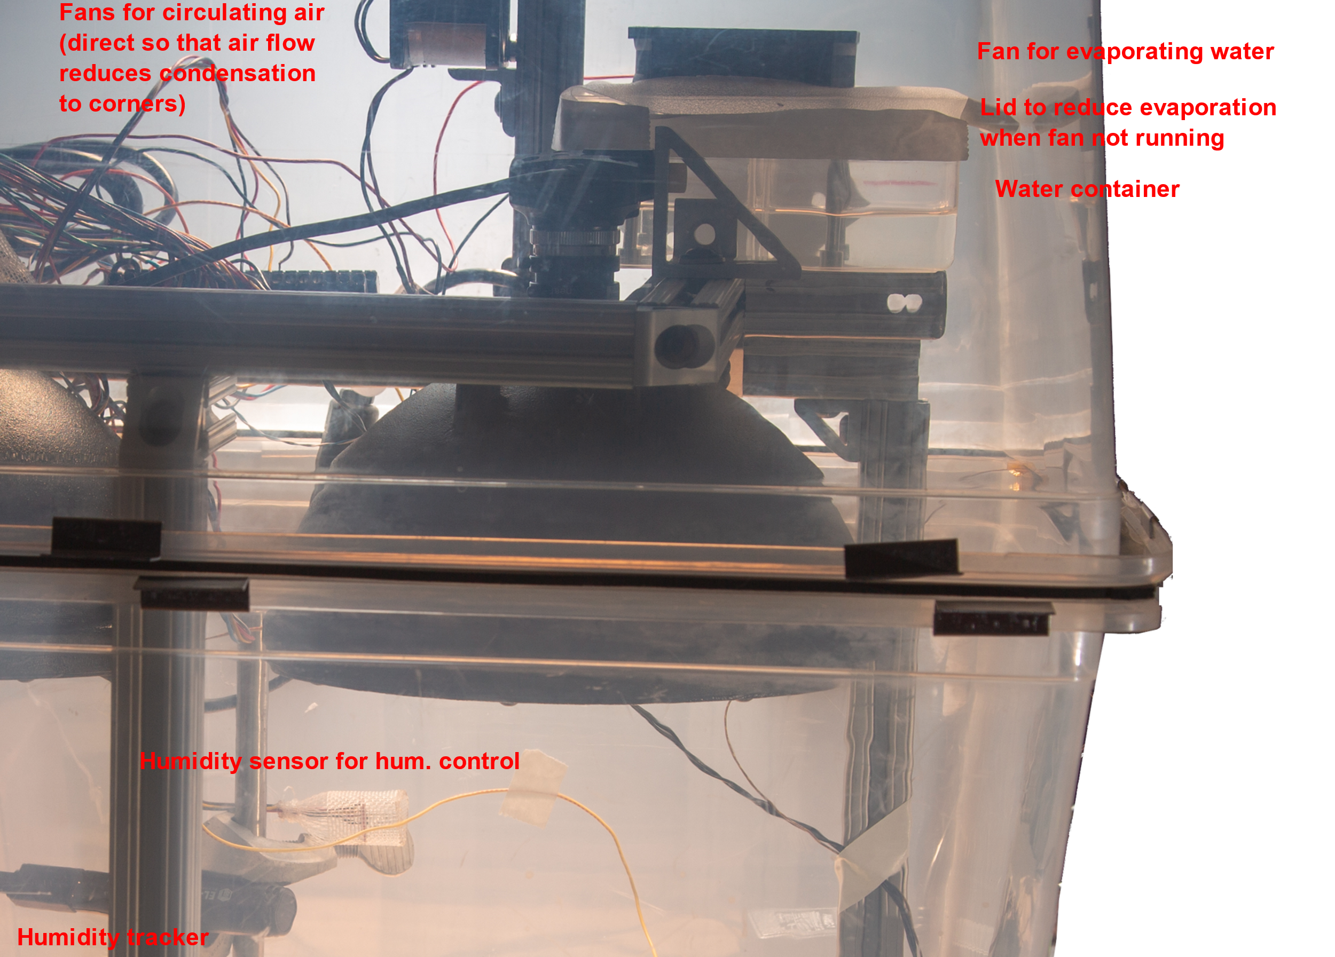

Figure VI: Humidity control and tracking components within the chamber.

**Humidity and temperature tracking setup**

1. Attach the tracker close to the sample holder area but so that it does not shade the sample holder or the printed color chart (connected to the laboratory bench holder in Figure VI).
2. Connect the tracker to the control laptop using a (preferably flat) USB cable, preferably via a USB hub. Turning the USB connection off whenever data is not retrieved from the tracker will extend battery life. This is because the tracker is always charging when the USB is connected.

**Sample Holder**

1. Mill the sample holder from graphite or other material that conducts heat. Dimensions are shown in the CAD drawing. The samples shelves are milled at 16 degree angles, such that the samples appear normal to the camera. Paint sample holder with grey matte paint that survives ultraviolet light, high temperature, and humidity.
2. Drill holes for the nails serving as sample alignment pins and attach the nails into the sample holder. When working with samples that accumulate charge under illumination, the metal pins serve as ground source, assuming the sample holder itself is grounded.
3. Drill a hole for the thermocouple to the side of the sample holder. Measuring the temperature from inside the sample holder is a viable approximation for the sample temperature if the substrates of the samples are relatively thin. This approximation should be confirmed with IR camera (with properly set emissivity estimate) when new types of samples are brought in.
4. Paint the sample holder to neutral gray.
5. Assemble the resistive heating module and tape it to the bottom of the sample holder with Kapton tape. The heat insulation mat can be attached to the sample holder with tape or left loose. See Figure IV for the assembled sample holder.
6. Place the thermocouple into the drill hole. Connect the thermocouple and heating module to the temperature controller and program the temperature controller according to the manufacturer’s instructions.
7. Use camera live feed to adjust the sample holder location so that it is horizontal and centered in the picture. Mark the exact sample holder location with alignment tapes to the floor of the chamber. Deviation from this alignment may cause light intensity variations between the samples, thus resulting in uneven degradation and reduced quality of data. The provided analysis code assumes the sample holder to be horizontally aligned in the image, pictures with tilted alignment lead to a smaller area of the sample being analyzed, thus less representative data.
8. Test the sample holder with targeted samples and live feed of the camera. Check for reflections or shadows distorting the color of the samples. Reposition the objects within the chamber if distortions occur. With mat samples, the sample tilting angle can be reduced, and with very reflecting samples, angle can be increased or diffuser added to the lamp to achieve more scattered light.

**Control**

1. Check that the laptop is connected to Arduino and camera.
2. If using Windows, set the system to not to restart automatically during system updates.
3. Configure a folder structure for the aging test data. The data folder should be backed up for security to a server or cloud. We recommend saving each aging test into its own folder. The analysis codes we provide assume that each folder contains one picture of the Xrite color chart (as the first image of the aging test), and pictures of the samples, nothing else.
4. Configure a metadata structure for the aging tests.
   1. We recommend the aging tests will be named by a unique identifier with fixed length (e.g., YYYYMMDD-RX-FL, where YYYYMMDD is the date of starting the measurement, X is the running number of the aging tests performed on that day, and FL are the initials of the corresponding researcher. This name can be used as the name of the picture folder and as the name of the metadata file(s).
   2. We recommend assigning one metadata file (e.g., txt file format) for free-form human input and keeping it open in the laptop whenever the aging test is running. This will make sure everything relevant (a rainy day, samples dropping to the floor, electricity cutoffs, accidentally shaking the chamber…) will be logged into the file even if the logging person would not be one of the trained users of the setup.
   3. We recommend assigning a metadata file to serve as a unique checklist for every aging test. This file should also have open fields for the values that need to be filled when starting or ending the aging test. We provide a minimum working example of such a file in the repository describing the MIT Gen 1 chamber: <https://github.com/PV-Lab/hte_degradation_chamber/metafile_aging_checklist_model.txt> (5/26/2022)
5. Install and test all the software and codes required in the use of the aging chamber. For MIT Gen 1 chamber, the codes are provided in two repositories: <https://github.com/PV-Lab/hte_degradation_chamber> and <https://github.com/PV-Lab/RGBanalysis> (5/26/2022).

**Test and calibration of the aging chamber**

1. Use infrared camera for testing the temperature distribution of the samples in the sample holder.
2. Use a reference solar cell with known quantum efficiency spectrum, quantum efficiency spectrum of the perovskite samples you test, and the spectral information provided by the lamp manufacturer (or measured by you) to calculate the effective intensity of the illumination for your samples.
3. Calibrate the humidity control system against the humidity-temperature tracker. The values should be within few percentage points from each other when the sensors are located next to each other and the Si7021 sensor is fresh. The deviation increases when the Si7021 sensor ages and should be compensated for by increasing the target humidity setting. When the difference becomes too high, the sensor should be changed.
4. Run the system for the intended duration of the aging tests and check if excessive condensation appears, that the humidity ramp-up rate is sufficiently fast for the intended samples (if the samples degrade very quickly, the humidity control fan can be swapped to a larger one or speed increased), and that the humidity and temperature of the chamber remain stable during the aging test. Check also (using the analysis codes provided) that the colors of the printed color chart remain stable during the aging test.
5. Run aging tests with samples to determine suitable camera settings and to establish a baseline of variations between the samples and within the sample. Camera settings should be chosen so that the white color patch of the Xrite color chart does not saturate to white (to RGB of 256/256/256), and the colors of typical samples do not saturate to black (to RGB of 0/0/0). See typical calibration results from section Extra Data within this manual.

**Software**

1. Download and installation instructions for the control codes of the chamber available in Github repository: <https://github.com/PV-Lab/hte_degradation_chamber> (5/25/2022).
2. A detailed video visualizing the use of the control software is provided in Youtube. Link provided in the Github repository: <https://github.com/PV-Lab/hte_degradation_chamber> (5/25/2022).
3. Download, installation, and use instructions for the result analysis available in Github repository RGBanalysis: https://github.com/PV-Lab/RGBanalysis (5/22/2022).

# **User Guide for MIT Gen 1 Chamber**

* Notes regarding the aging test are to be made in the “metafile_aging_checklist” file. Rename a copy of this file according to the name of your aging test and fill in the blanks.
* A video visualizing the chamber usage is provided in Youtube. Link provided in the Github repository: <https://github.com/PV-Lab/hte_degradation_chamber> (5/25/2022).
* Initial preparations
  + Activate/connect the USB port for the humidity tracker. Open the EasyLog Humidity Tracker App on the computer (Figure VII).
    - Stop the humidity meter, collect the data and save it on the laptop.
    - Restart the humidity meter.
    - Deactivate/disconnect the USB port, and check that the green LED of the humidity meter blinks in every 1 min.

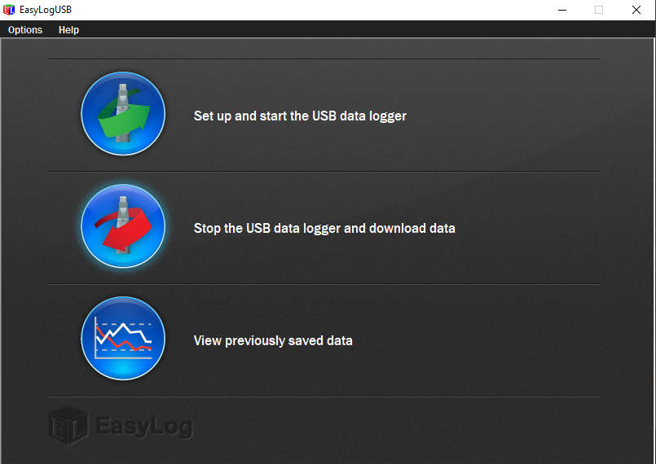

Figure VII: View of the control program for the humidity tracker.

* + Check that the USB port for Arduino is active. Open the Arduino program for humidity control.
    - Navigate to Arduino/Tools/System monitor. The program starts printing out current sensor values.
    - Check that the humidity control system reads a valid number (humidity <100%).
    - Set “Desired_Humidity” level.
      * Account for error in the reading of the humidity tracker (Explanation: If the Humidity tracker reads 58%, the humidity controller reads 61%, then the error in the humidity controller is approximately +3%. If you want to set the chamber humidity to 50%, you must enter – 53%).
      * Once ready, press “Verify” and “Upload” in the upper left corner (Figure VIII).

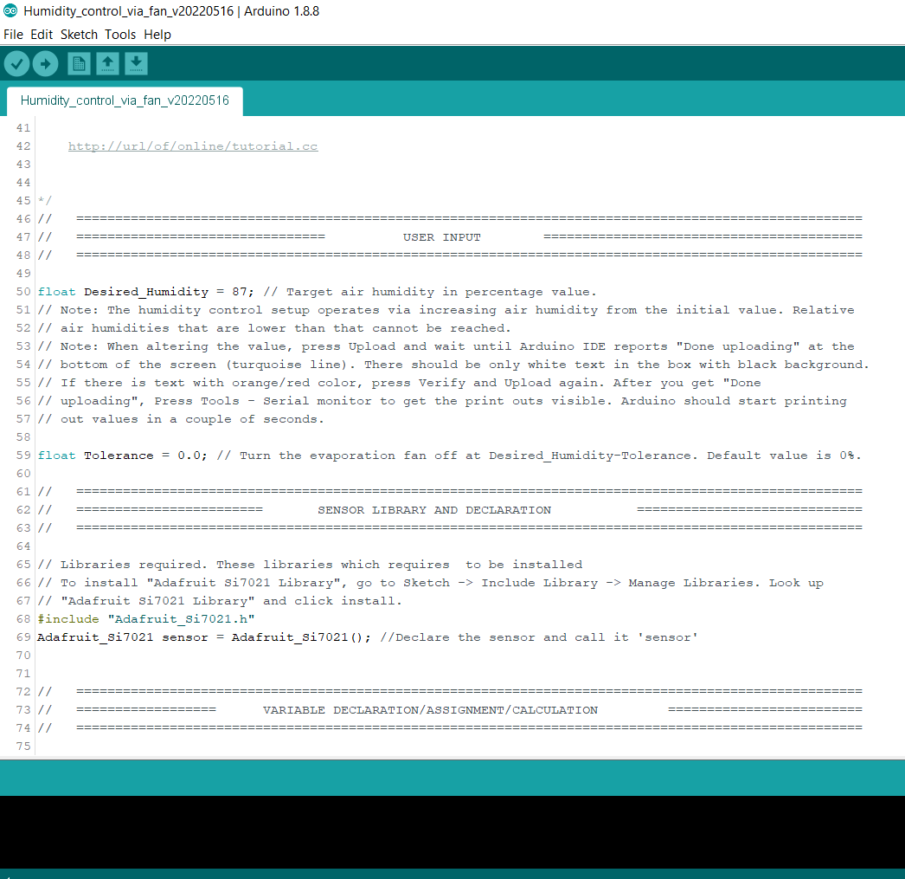

Figure VIII: Humidity control program runs the Arduino.

* + Open the LabView camera control program.
    - Press white arrow in the upper left corner to run the VI (Figure IX).
    - Feed in camera settings (Figure IX).
      * Reference values that typically work: pixel clock 24 / frame rate 15 /exposure time 7.35 ms.
      * Optimal settings for the camera will vary by time, depending on the sample color and lamp aging. Use the same settings during the whole project. You will need to perform a calibration procedure to determine these values. See “Build Guide” – “Test and calibration of the aging chamber” for further instructions.
    - Scroll to the right of the front panel (Figure IX). Enter the path to the data folder (cloud or server folder). Enter frequency of capturing images.
    - Scroll to the left of the front panel (Figure IX). Press “Start Live”
    - Check that the data is saved into your folder.

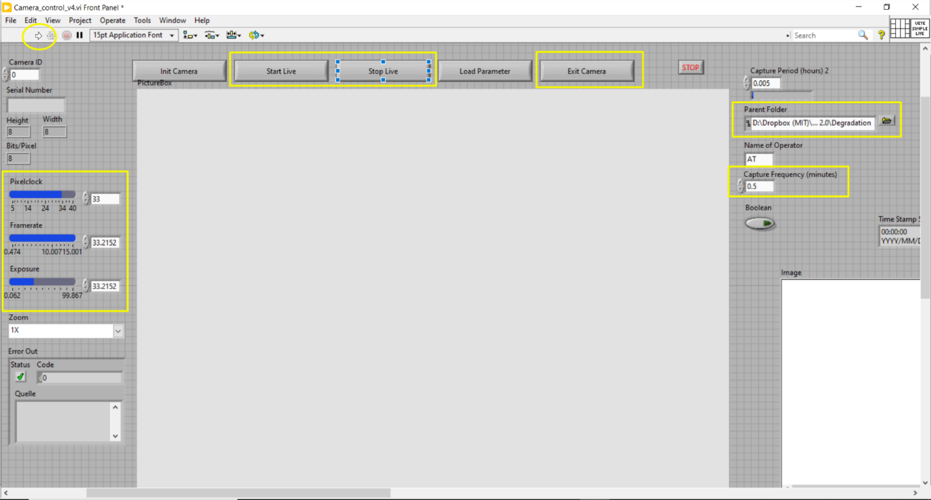

Figure IX: Camera control program. View of the front panel.

* + Turn the lamp on.
  + Take a photo with Xrite reference color chart as the first photo of the aging test.
    - Remove the sample holder from the picture area but leave the insulating pad there. Place the Xrite color chart to the picture area on top of the pad so that its lower right corner (i.e., the corner with white color patch) is aligned with the green tapes marking the sample area and it is aligned straight in the live stream of the camera program.
    - Wait until one picture of the chart has been captured by the camera control program.
    - Open the color chart picture with GNU Image Manipulation Program (GIMP). Navigate to Colors -> Map -> Color Exchange option and check that the white color patch is not oversaturated (i.e., RGB 2must remain below for most of the white pixels 256/256/256). This is just to check the camera settings; you should not save the changes to picture.
    - Remove Xrite color chart and place the sample holder back to its place.
  + Turn on the large fans. Null the timer and fill the water container until the level marked in the container (for experiments with higher than room humidity, otherwise clean to complete dryness). Check that there are no wires that could cause shadows or reflections on the samples.
* Putting the samples in
  + Insert all the samples in and log the sample order in the metadata file. Ensure that you are wearing gloves and place the samples on the holder very carefully using tweezers. Avoid dropping the samples or getting scratches on them as this could impact the degradation process.
  + Check that the sample holder is aligned straight in the picture and it is positioned into the sample area (green tapes) in the live view of the camera control program.
  + Turn on the sample holder heating and set to the desired temperature.
  + Close the lid and put the curtain on the apparatus.
  + If there are multiple pictures of the Xrite color chart or pictures of the partially filled sample holder, delete them at this stage since the picture analysis program assumes that the first picture of the aging test is of Xrite chart, and the rest are of the filled sample holder.
* Winding Up
  + Log the temperature reading, humidity reading and sample holder temperature into the metadata file. Do the same after 10 minutes and after an hour (optional).
  + Check that images are being loaded into the Dropbox folder and that everything is running fine.
  + When you are ready to end the test, note the duration of the test, temperature reading, humidity reading and sample holder T into the metadata file.
* Shutting Down
  + Turn off the parts of the chamber in reversed order compared to Initial preparations.
    - Camera control program: Press “Stop Live”, “Exit Camera”, and turn off the program.
    - Deactivate/disconnect USB port, turn off Arduino IDE, and turn off fan power supplies.
    - Humidity tracker: Activate/connect the USB port, load and save the tracker data via EasyLog Humidity Tracker App with the name of your aging test, deactivate the USB port.
  + Remove the lid carefully and without shaking in case that there is condensation on the lid that could damage the samples if drops are falling on top of the samples. Don’t breathe in the fumes if you smell anything.
  + Remove the samples.

# **Maintenance and Troubleshoot Guide**

* Maintenance
  + Replacing Si7021 sensor
    - Must be done approximately every 1 month or when the humidity reading begins to deviate from the reference value (EL-USB-2). The advised maximum humidity for the Si7021 sensor is 80%, thus the sensor ages especially during high humidity aging tests.
  + Replacing XRite ColorChecker Passport
    - Must be done when the colors fade, manufacturer recommends every 18-24 months.
  + Replacing the printed out color chart from within the chamber
    - Must be done when the colors fade
* Troubleshoot
  + Variations in the color data
    - Is the illumination intensity sufficiently even in the picture area?
      * Place a sheet of paper with the color of samples in the picture area to determine the level of spatial variations by taking a picture.
      * Check the alignment of the camera and lamp, and possible reflections from nearby objects, adjust the positions accordingly and attach the components securely.
      * Check that all the LEDs in the lamp turn on, change the lamp if necessary.
    - Is the sample holder heating the samples evenly?
      * Use IR video camera to determine the spatial variations
      * Are the thermocouple and resistive heater properly attached to the sample holder?
    - Are the blackout curtains covering the whole chamber? Outside illumination may distort the data.
    - Make sure of using manually fixed settings of the camera if you are using another camera control program than what is provided here – camera settings may drift over time if they are set to automatic mode.
  + Flickering of the lamp
    - This is likely due to a ground loop issue. Make sure that every object in the chamber is in the same ground loop (with grounding wires where necessary). If there are objects that are floating and cannot be grounded securely, use plastic bolt for attaching them to the chamber.
    - Make sure the lamp controller is wired to a fixed voltage instead of the dimming control channel floating freely.
  + Condensation within the chamber
    - Check that he humidity tracker and humidity sensor are located near to the samples in order to measure conditions that the samples re facing as accurately as possible
    - Has the humidity sensor become saturated? Swap the sensor if necessary
    - Check that the air circulation is reaching out every corner of the chamber, adjust fan locations accordingly
    - Check that the black-out curtains are covering the whole chamber (they serve also as an insulating layer)
    - Dry out the chamber in between the aging tests if repeating multiple aging tests in a row
    - The chamber is prone to condensation with higher than 80% relative humidity levels combined with high temperature for the samples – shorten the aging test duration or decrease the humidity level if the problem cannot be solved otherwise
  + Humidity control programs shows NaN humidity
    - Si7021 connections might have gone loose. Check the connections.
    - The setup is sensitive to voltage peaks – has there been electricity cutoffs recently? If yes, it may be necessary to change the sensor.
  + Humidity control program is irresposive
    - USB connection to Arduino might have gone loose. Check the connections.
    - Arduino may have been busy when you tried to upload the updated code. Power off everything, restart, and try again.
    - The microprocessor is sensitive to voltage peaks – has there been electricity cutoffs recently? If yes, it may be necessary to change the Arduino.

# **Bill of Materials**

The chamber components are listed in detail below. The costs of the main components are shown in the accompanying Excel file (MIT Gen1 Chamber BOM.xlsx). The total cost of the chamber is in the range of US$2.000-5.000 depending on the amount of repurposed materials available.

* Chamber
  + 2 pcs of 66 quart / 62 L Sterilite ClearView plastic home storage boxes
    - Dimensions (W x L x H, cm): 60.0 x 41.6 x 33.7
    - Design rules: rectangular shape to reduce condensation near the insets, rounded rims to make it easier to seal the chamber, sufficient size to fit in the Al frame.
  + 205 cm of foam insulation tape
  + 8 pcs of fold back clips
    - Width 41 mm
    - Design rules: Sufficient jaw opening to clip the top and bottom containers of the chamber together
  + Optional: 16 pcs of steel contact points for the fold back clips
    - For making it easier to close the chamber with fold back clips
    - Dimensions (W x L, mm): 30 x 60
    - Bending instructions in the build guide
  + 2 pcs of black out curtains
    - Dimensions (W x L, cm): 145 x 250
* Support frame
  + Aluminum profiles
    - Dimensions: see CAD drawing
    - Assembled according to the CAD drawing
    - Design rules: square profile with one rail on each side
  + 17 pcs inside corner brackets
    - For joining the Al profiles
    - The number and type required depends on the Al profiles chosen, check for your profiles
  + 3 pcs of inside corner brackets with sliding slot
    - Dimensions (W x L x H, cm): 2.5 x 2.5 x 1.8
    - 1 pc for attaching the camera
    - 2 pcs for attaching the water reservoir for the humidity control system
    - Design rules: matches the aluminum profiles, is sufficiently large for attaching the water container securely in place to sit on top of aluminum frame, has a sliding slot for attaching the camera
  + Bolts and nuts for attaching the fans, lamp, and camera to the aluminum frame
* Lamp
  + Lamp dome: Advanced Illumination DL097
    - Inner diameter 155 mm
    - Design rule: circular LED placing and back-reflection from white inner dome to create an even diffuse illumination pattern, sufficient diameter for creating even illumination for the intended sample holder size (here 10 cm x 10 cm)
  + Lamp controller: Advanced Illumination ICS IC inline controller
    - Design rule: matches the lamp, DC gating on/off and dimming to control the lamp intensity
  + 24 VDC power supply
* Camera setup
  + Camera: ThorLabs DCC1645C
    - Main features: 1280 x 1024 pixels, CMOS.
    - Infrared filter removed and replaced with plain glass by a request to the manufacturer
    - Design rule: sufficient resolution and color sensitivity for the intended application
  + Camera Lens: ThorLabs MVL6WA
    - Main features: 6 mm focal length, max. aperture 1.4, min. object distance 200mm, field of view 69.4°
    - Design rule: capable of focusing on the intended size of the picture area (here picture area with sample holder and small color chart is approximately 20 cm of diameter) from the intended distance (here distance between the sample holder top and camera lens is 310 mm)
  + Plastic bolt
    - Design rule: For attaching the camera to the sample holder, is required if the control laptop and the lamp/aluminum frame lie in a different potential level (otherwise, static charge accumulates and is released when the setup is shaken, resulting in the lamp flickering and faulty picture data as a result)
  + Flat USB cable
* Color calibration setup
  + XRite ColorChecker Passport
    - For color calibration
  + Printed out 24-patch Gretag Macbeth color chart
    - For following the stability of the lamp
    - Multiple sources, e.g.: <https://babelcolor.com/colorchecker.htm#xl_CCP1_ChartsFormats> (5/25/2022)
  + Tape for attaching the printed out chart to the bottom of the chamber
* Humidity control setup
  + 2 pcs of 120 mm desktop computer fans
  + 24 VDC power supply for the 120 mm fans
  + 1 pc of 80 mm desktop computer fans
  + 24 VDC power supply for the 80 mm fan
    - Design rule: if the fan does not rotate with 12V, use 24V power supply
  + Water container
    - Dimensions (W x L x H, cm): 10 x 14 x 5.5
    - Design rule: Must be wider than 80 mm to fit in the computer fan
  + Lid for the water container
    - 70 mm x 70 mm hole cut out to fit in the computer fan
    - Holes drilled for attaching the computer fan
  + Arduino Uno Rev3 SMD
  + Adafruit Si7021 temperature-humidity sensor
  + Additional components
    - 3.3 k-ohm resistor
    - Diode
    - NPN transistor
    - Green LED
    - Connecting plate
    - Jumper wires and wires for connections
    - An electrical board box
      * For protecting the connections from getting loose
      * Design rule: Needs to fit in Arduino, connecting plate, and the wires
    - Screw terminal
      * For collecting wiring inside the chamber and leading it out from the chamber (because it is easier to maintain the chamber if there are no long wires)
* Humidity and temperature tracking setup
  + Temperature and humidity Tracker: Lascar Electronics EL – USB – 2
  + Flat USB cable
  + Laboratory bench holder
    - For attaching the tracker near to the samples
    - Design rule: needs to be compatible with the rails of the support frame
* Sample Holder
  + Dimensions: see CAD drawing
  + Material: Graphite
  + Paint: Neutral gray
  + 24 pcs of small nails
    - For aligning the samples and for grounding them to prevent build-up of static charge
  + 24 drill holes for the nails
  + 1 drill hole for the thermocouple
  + Resistive heating module
    - To be taped to the bottom of the sample holder
    - Components
      * Resistive heating wire
      * Kapton tape
      * K type thermocouple
      * Solo 4824 temperature controller
  + Heat insulation mat
    - For preventing the chamber plastic from melting when the sample holder is heated
    - Dimensions (W x L, cm): 9 x 9
  + Paper tape for marking the exact sample holder location in the picture area
* Control
  + Laptop
  + USB 3.0 Switch Hub with the option to switch a port on/off
    - For connecting humidity/temperature tracker
      * Design rule: tracker port should be turned off when not used for collecting the data to increase the battery life of the tracker

# **Extra Data**

Sample order in the sample holder and in the pictures produced

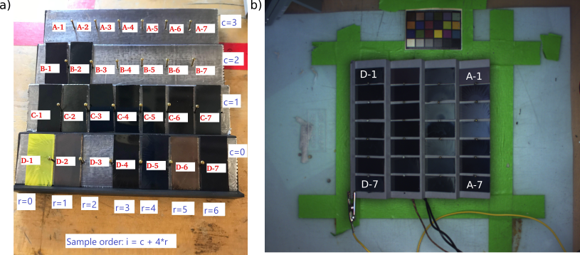

Figure X: Sample indexing viewed a) from the front of the chamber and b) in the resulting pictures. Sample index in the analysis codes is i, calculated based on the equations shown. To facilitate comprehending the sample location in the chamber and to avoid mistakes in sample indexing, a letter-based naming system is also used in the resulting tables. It names the columns of the sample holder from A to D, and positions from 1 to 7 as illustrated.

Light intensity calibration result

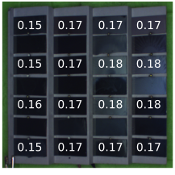

Figure XI: Exemplary light intensity calibration result of MIT Gen. 1 chamber. Intensities shown as Suns experienced by MAPbI3 samples.

Spatial temperature uniformity of the sample holder

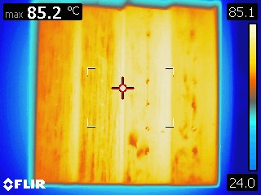

Figure XII: Uniformity of the temperature across the sample holder in MIT Gen 1 chamber.

Longitudinal stability of the humidity and temperature within the chamber

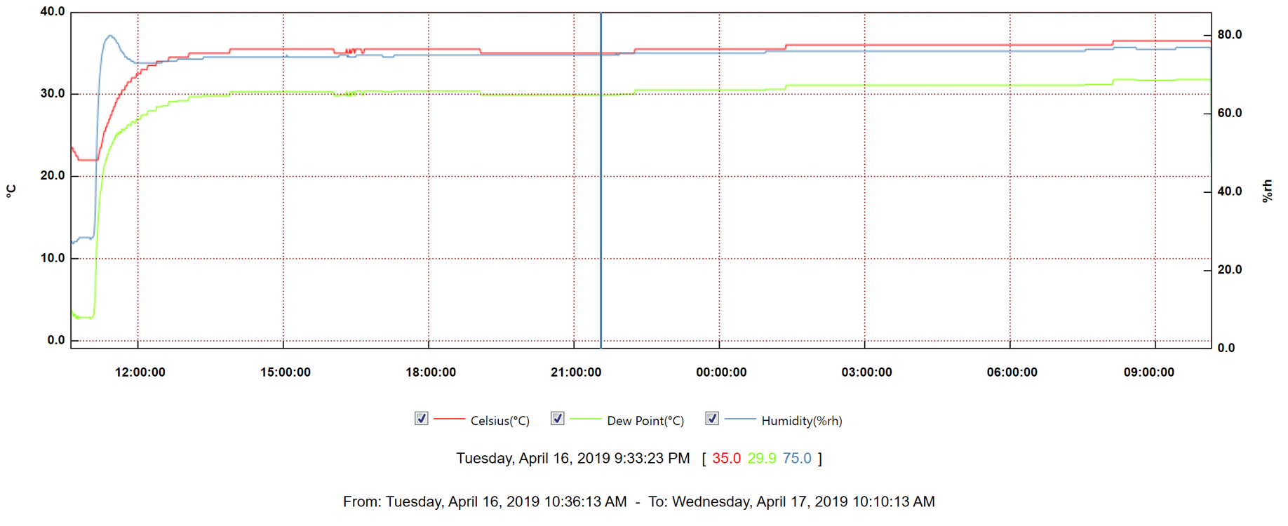

Figure XIII: Longitudinal stability of air humidity and temperature in MIT Gen 1 aging chamber during a 23.5-hour aging test. Relative air humidity (%rh) shown with blue color, temperature (°C) shown with red color, and dew point (%rh) shown with green color. Direct output graph from the humidity tracker software shown.